Hourly Stats from Monday, November 9, 2015 to Sunday, November 15, 2015.
With all days of the week. ## With all times of the day. ## With all glucose values.
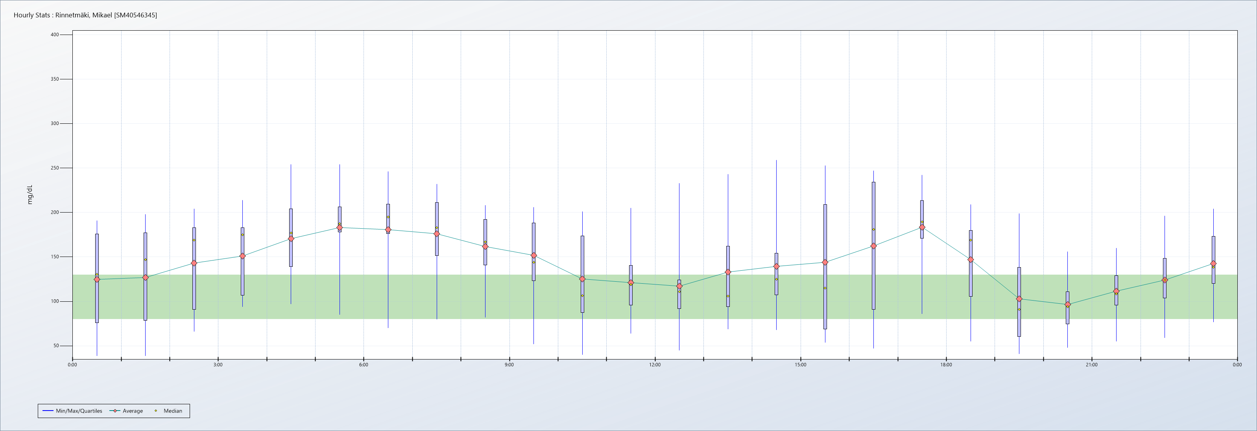

Stat | Totals | 0 | 1 | 2 | 3 | 4 | 5 | 6 | 7 | 8 | 9 | 10 | 11
# of Readings | 1937 | 84 | 84 | 77 | 65 | 70 | 84 | 84 | 84 | 84 | 84 | 82 | 83
Average | 142 | 125 | 127 | 143 | 151 | 171 | 183 | 181 | 176 | 162 | 152 | 125 | 121
Min | Low | Low | Low | 66 | 94 | 97 | 85 | 70 | 80 | 82 | 52 | 40 | 64
Quartile 25 | 98 | 76 | 79 | 91 | 107 | 139 | 178 | 177 | 152 | 141 | 123 | 87 | 96
Median | 141 | 131 | 147 | 169 | 175 | 177 | 188 | 195 | 183 | 167 | 144 | 107 | 119
Quartile 75 | 184 | 176 | 177 | 183 | 183 | 204 | 206 | 210 | 211 | 192 | 188 | 174 | 141
Max | 259 | 191 | 198 | 204 | 214 | 254 | 254 | 246 | 232 | 208 | 206 | 201 | 205
Std. Dev. | 52 | 49 | 56 | 48 | 40 | 44 | 46 | 48 | 43 | 36 | 39 | 48 | 33
Est. Std. Dev. | 64 | 74 | 73 | 68 | 56 | 48 | 21 | 24 | 44 | 38 | 48 | 64 | 33
IQR | 86 | 100 | 98 | 92 | 76 | 65 | 28 | 33 | 60 | 52 | 65 | 86 | 44
SE Mean | 1 | 5 | 6 | 5 | 5 | 5 | 5 | 5 | 5 | 4 | 4 | 5 | 4
%CV | 37 | 39 | 44 | 33 | 27 | 26 | 25 | 26 | 24 | 22 | 26 | 38 | 27

Stat | Totals | 12 | 13 | 14 | 15 | 16 | 17 | 18 | 19 | 20 | 21 | 22 | 23
# of Readings | 1937 | 81 | 77 | 72 | 72 | 83 | 84 | 84 | 84 | 84 | 84 | 83 | 84
Average | 142 | 117 | 133 | 139 | 144 | 162 | 184 | 147 | 103 | 97 | 112 | 124 | 143
Min | Low | 45 | 69 | 68 | 54 | 47 | 86 | 55 | 41 | 48 | 55 | 59 | 77
Quartile 25 | 98 | 92 | 94 | 108 | 69 | 91 | 171 | 106 | 61 | 75 | 96 | 104 | 120
Median | 141 | 111 | 106 | 125 | 115 | 181 | 190 | 169 | 91 | 94 | 109 | 124 | 139
Quartile 75 | 184 | 124 | 162 | 154 | 209 | 234 | 213 | 180 | 138 | 111 | 129 | 149 | 173
Max | 259 | 233 | 243 | 259 | 253 | 247 | 242 | 209 | 199 | 156 | 160 | 196 | 204
Std. Dev. | 52 | 45 | 52 | 57 | 73 | 70 | 40 | 48 | 47 | 28 | 24 | 34 | 34
Est. Std. Dev. | 64 | 24 | 50 | 35 | 104 | 106 | 31 | 55 | 58 | 27 | 25 | 33 | 39
IQR | 86 | 32 | 68 | 47 | 140 | 143 | 42 | 74 | 78 | 36 | 33 | 44 | 53
SE Mean | 1 | 5 | 6 | 7 | 9 | 8 | 4 | 5 | 5 | 3 | 3 | 4 | 4
%CV | 37 | 39 | 39 | 41 | 51 | 43 | 22 | 32 | 46 | 29 | 22 | 27 | 24

